Adithya.J

230701013 CSE A

EXP NO:8 PRODUCER CONSUMER USING SEMAPHORES

PROGRAM

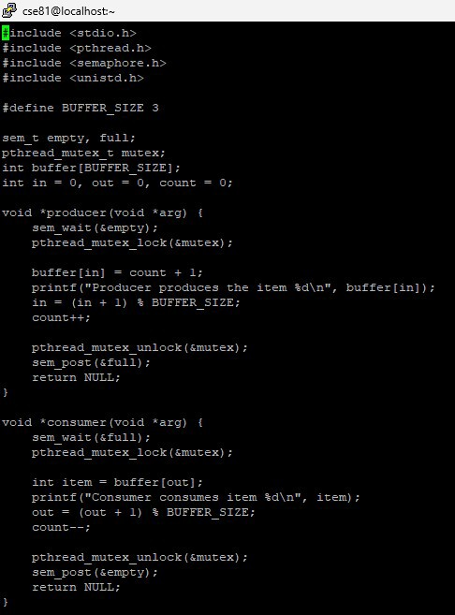

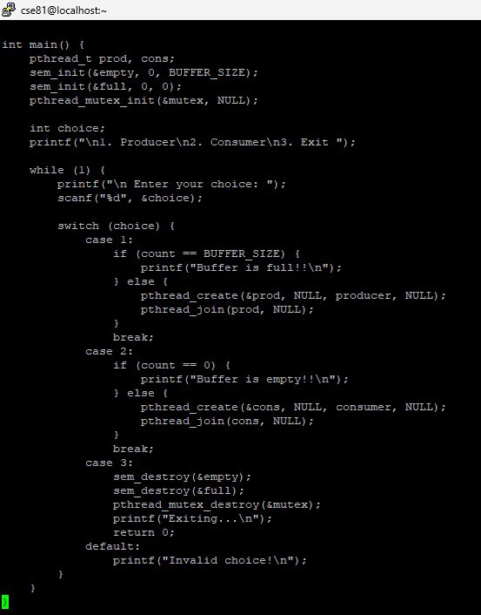

OUTPUT

